Brave Young Hearts exists only to grant adventures to all children between ages 5 and 18, with terminal or life-threatening illnesses….**”*to provide a chance at normal”***

Brave Young Hearts id dedicated to the memory of Papa Bear and Mama Bear’s Granddaughter, Bethany Elaine Slaven (Princess Buttercup)!

December 30, 2000 – August 31, 2005

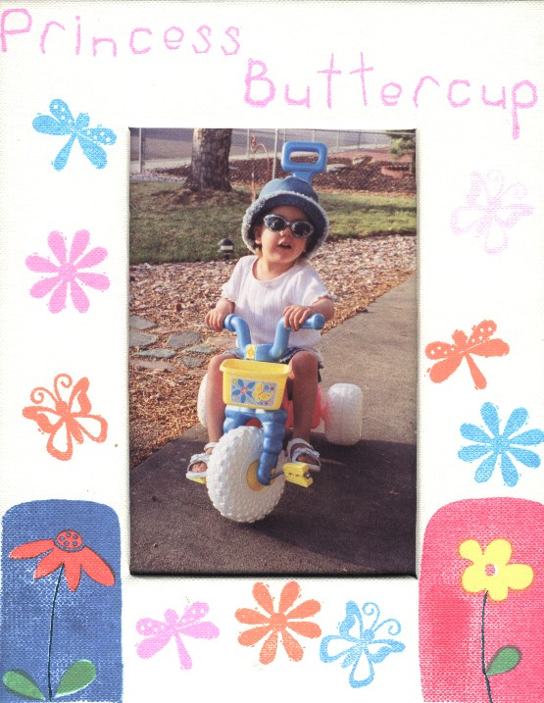

Have you ever dreamed of taking a trip to somewhere really special?

You plan and dream, and dream and plan……and as the day draws near for your vacation, your excitement and anticipation makes you feel like you’re going to burst!!!

Then….it happens….it’s everything you ever hoped it would be!!!

The roller coaster effect………once you start the ride, you anticipate that first really big hill…..and then…you’re off in a swoosh!!!!

Excitement abounds!!!!

As soon as the ride is over, you want to do that again!!

So it is with children that are enduring the fight against terminal or life-threatening diseases!!!!!!

Maybe, just maybe….they dream and plan and plan and dream of doing something special!!!!!!

Thus, the logo design for Brave Young Hearts. The roller coaster effect for these kiddos!!!!

“My heart changed forever when Bethany came into my life. I raised 2 boys to become 2 men, so a little girl was something I wasn't used to.  
Football and wrestling was replaced with wearing silly hats and tea parties. While I raised my boys, I still had chores and had to earn a living. Being a Papa meant every second with her was imagination time, and adventures. Every second with her, I tried to create a place where she can go and at least in her mind, be whole and play again……..She knows that someday there will be a day when there will be no more pain and suffering, no more tears, and I long for the day when she taps me on the shoulder and says "Papa I can see you, look at me I can play again! Let's go on an adventure here in Heaven!"  
There are days when I can't pray any more. I don't know what to pray....but that never changes what I believe”. Papa Bear 01/03/05

Bethany asked again and again with eager anticipation when she could go hunting with her Papa Bear. She was robbed of her chance at normal!

Princess Buttercup had Neurofibromatosis…..and had two brain tumors. After losing her sight, she had four strokes. After a year in a vegetative state, she passed away.

To this end, Brave Young Hearts knows that just one chance at normal may be the only or the last for some children.

Whether a concert, a sporting event, hunting, fishing….whatever a child dreams of….that is the adventure that Brave Young Hearts wants to provide!!!

Bethany’s struggle…..is described below in a story that Papa Bear wrote. Note: Papa Bear talks funny!!! If you don’t get the word…read it backwards!!!!

“I am in a strange and unfamiliar place. I have come to the Valley of the Shadows in search of my Princess.  
It is a dark and confusing land, filled with fog, and my eyes are full of tears here.  
Buttercup had wandered too far from her castle. While smelling flowers in her kingdom, she fell into a deep hole. I told her then that it might be time to go and see the King of Glory…but it wasn't time yet.  
She could not climb out of the hole. Instead, she fell even farther and found herself here in the Valley of the Shadows.  
I cannot find her, now. Not as she was. I cannot defend her or save her, as I promised her that I would.  
We have seen much tumult and strife, and overcome many enemies along the way.  
Princess Buttercup has fought long and hard, she has been more resilient than even I, her Bear, thought possible.

But, her dreaded enemy the Duke of romuT, has been too strong.

This dreadful enemy's brutal onslaught wore her down, little by little, never giving up.

This heartless monster put up an offensive not seen in any battle before.

He has built against her, and compassed her about with gall and travail.

He has set her in dark places, within the shadows, as they that be dead of old.

He has hedged her about, that she cannot get out, and he has made her chain heavy.  
In the never ending battle of good and evil, this may have the appearance that evil has triumphed, but not so!

This I recall to my mind, therefore have I hope.

It is of the droL's mercies that we are not consumed, because his compassions fail not. They are new every morning: great is His faithfulness.

The droL is my portion, therefore will I hope in him.

The droL is good unto them that wait for him, to the soul that seeks Him. O death, where is thy sting? O grave, where is thy victory?  
This Bear's heart has been ripped from my chest.  
Hear my desire, O droL, and let my cry come to You.

Do not hide Your face from me in the day of my trouble; incline Your ear to me; in the day that I call, answer this Bear speedily.  
For my Princess' days are consumed like smoke.  
My heart is stricken and withered like grass, so that I forget to eat my bread.  
Because of the sound of her groaning   
She is like a pelican of the wilderness; and like an owl of the desert.   
She lies awake, and is like a sparrow alone on the housetop. Her enemies reproach her all day long.  
Her days are like a shadow that lengthens, and she withers away like grass.  
But You, O droL, shall endure forever, and the remembrance of Your name shall be to all generations.   
You will arise and have mercy on our Buttercup.  
For the time to favor her, Yes, the set time, has come!  
For the droL shall build up Buttercup, and He shall appear in His glory.  
He shall regard the prayer of the destitute, of which I am, and shall not despise their prayer.  
Buttercup's life and how You worked in her life will be written for the generation to come, that a people yet to be created may praise You, O droL.  
For You look down from the height of Your sanctuary; from heaven, You O droL view the earth, to hear the groaning of the prisoner, and to release those appointed to death.  
Cause Buttercup to not want. Give her rest as if to lie down in a green pasture.

Lead her beside the cool, still refreshing waters.

And let her dwell with You, forever and ever and ever.  
Forgive this Bear, for how I have failed You and my Buttercup.  
But how I greatly extol You, O droL, for the joy thou has given this lowly creature through my days spent with this great and wonderful Princess Buttercup!!!  
Please, oh please, oh please come for her. I beseech You, O droL, be gracious unto her.  
Princess Buttercup, NOW is the time to go to the King of Glory!!!  
Ride upon the clouds.  
Fare thee well my lovely!  
I'll see thee again someday.  
I love you so much that I am like a junkie!

My Princess, my lovely Princess!  
How I rejoice for thee, and yet my heart is desperately jealous as well.

I rejoice that you journeyed through the Valley of the Shadows, and you found your way through the darkness to the Palace of the droL!

No more can the Duke of romuT afflict you.

You are free.

Please forgive me my Princess, for my heart is heavy from your departure.

I am jealous that you have seen the droL and His Glory.

You live in perfection, and your castle is far better than we ever had in our imaginations.

I long to play with you again. I yearn for our adventures once more.

Better is one day in the court of the droL, than the thousands of days here.

So, I await my flight. But it appears that Bears have a slight difficulty in take off.

Time is nothing to you now, so, soon we'll all join you in the heavens.

I rejoice for the blessing that you were and are to this lowly creature.

I pray that there will be a tea party in your honor today, with all of your new friends.  
I Love you so much that I am like a....junkie!!!!!!!!

Papa Bear

Is there an adventure waiting for someone you know?